1. Create a separate worksheet from the original data set



2. Select ALL -Remove duplicates. By selecting all column means that if all columns selected have duplicates it will be removed. IF ONE OF THE COLUMN SELECTED HAS NO DUPLICATE EVEN ALL THE REST HAVE DUPLICATE THEN THAT ROW WILL NOT BE DELETED

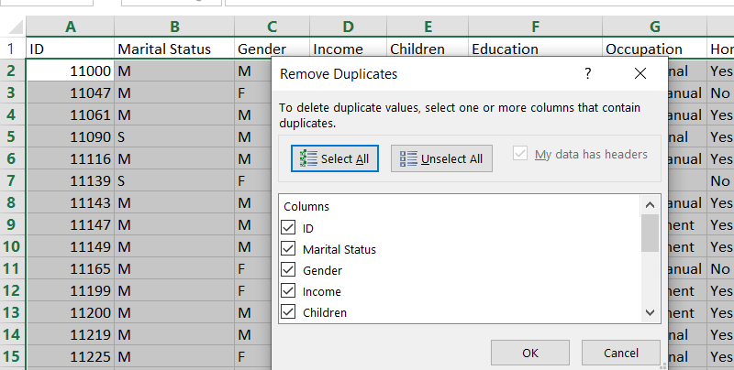 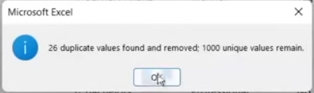

3. SELECT COLUMN + “Ctrl + H” = fast replacing value on columns.

Choose in Search: By columns and check “Match case”

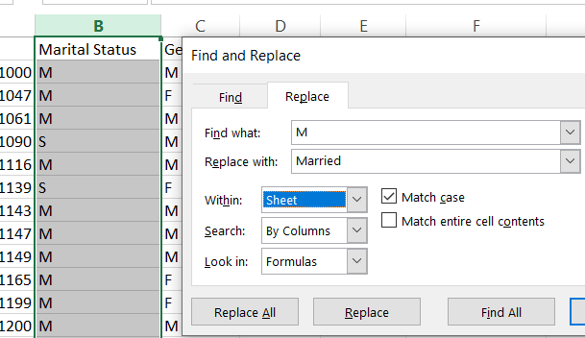 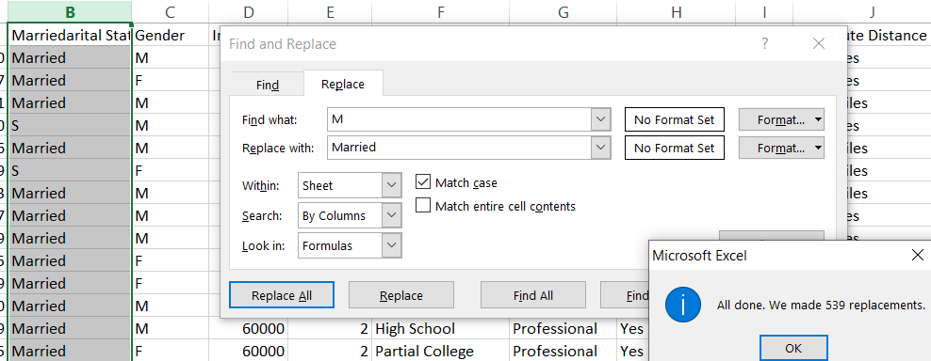

4. IF statement to add age bracket

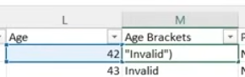 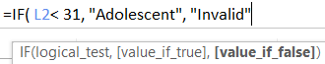

NESTED IF where the first IF statement is used as an argument for ‘value_if_false’

 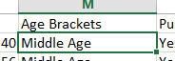

Note: you can apply a formula to an entire column without dragging. Here are a few easy methods:

**Double-click the fill handle** 

If the adjacent column has data:

* Type your formula in the first cell.
* Hover over the small square at the bottom-right corner of the cell (the fill handle).
* **Double-click** the fill handle.
* Excel will auto-fill the formula down as far as the adjacent column has data.

NESTED-NESTED IF statement where the first and second IF statement is the “value_if_flase”

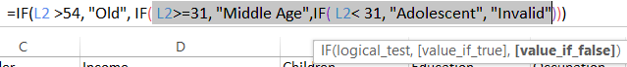 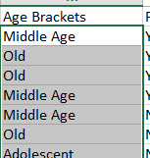

5. Press ctrl + A while in the worksheet while you are creating pivot table to select Table/Range

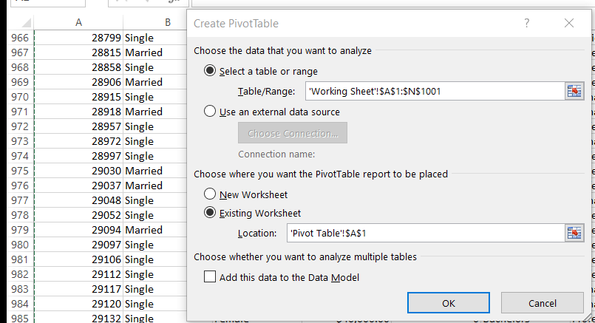

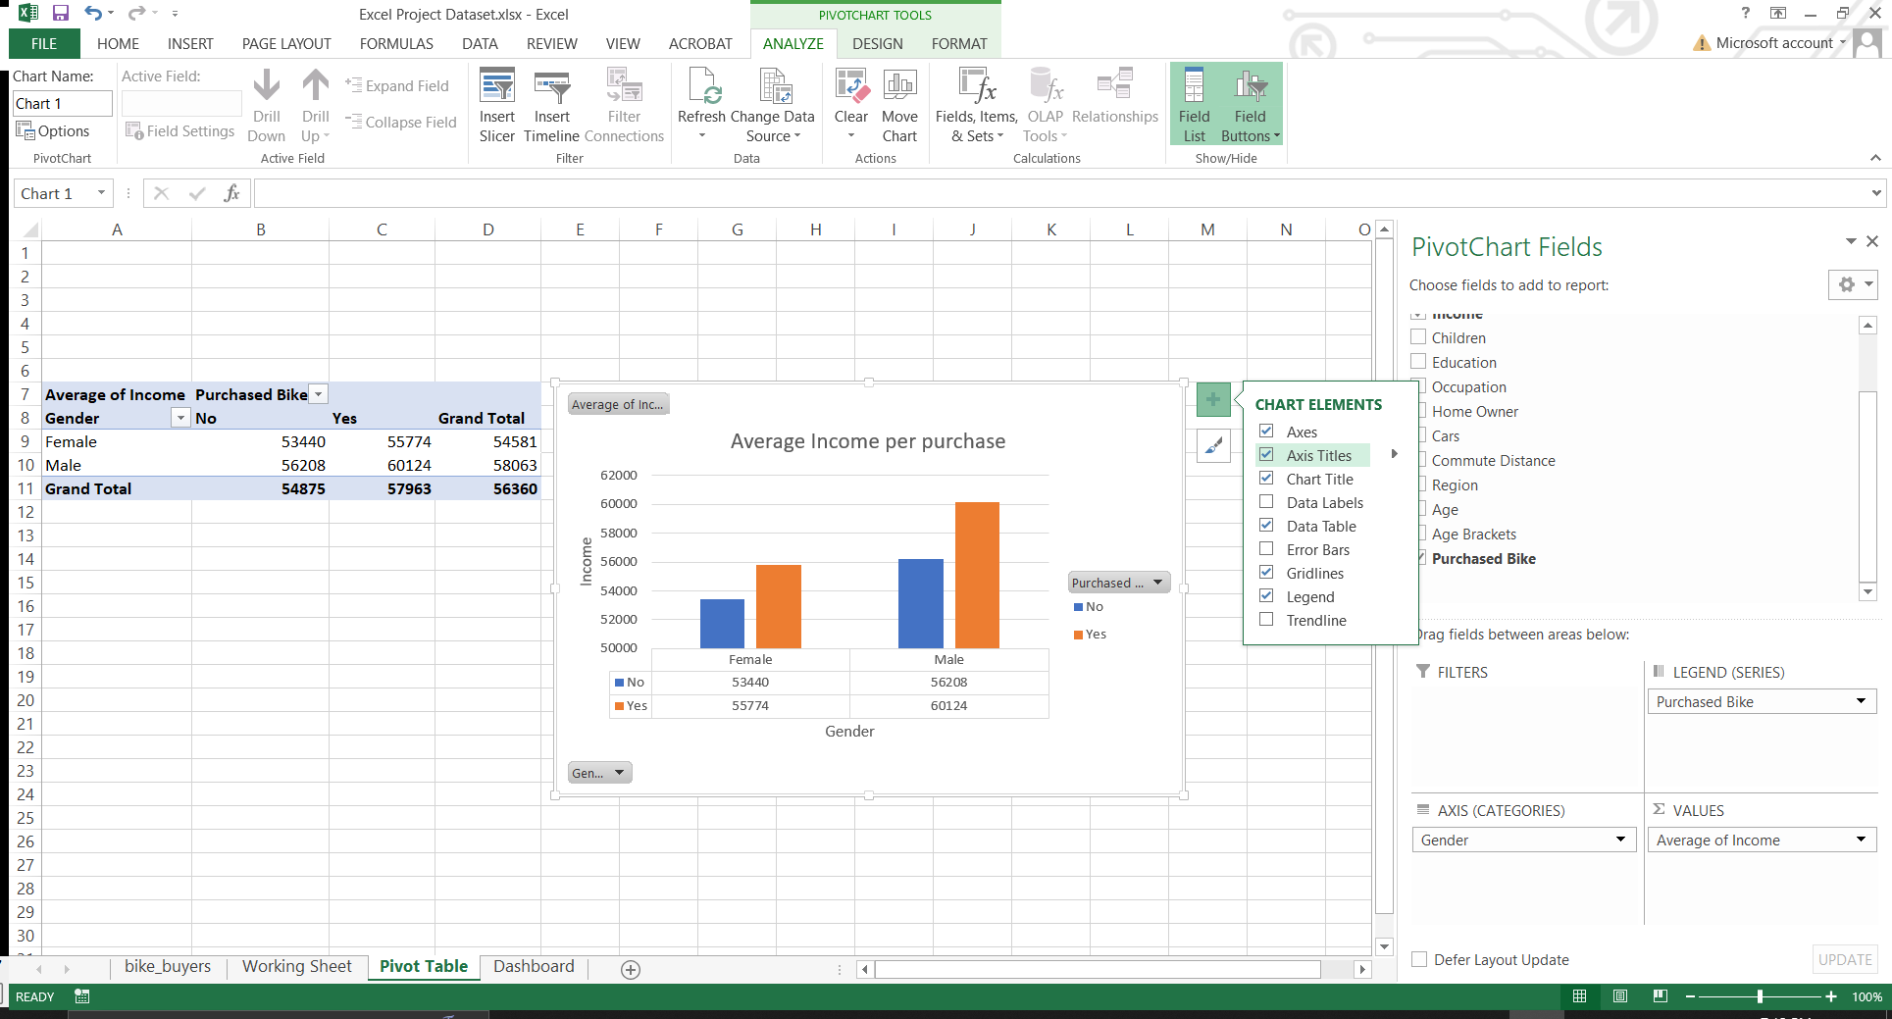

Another pivot table was made and there is a problem on the order. The “10+ Miles” should be on the last but even though changing order it is not going to the last. This is because it is already in ascending order

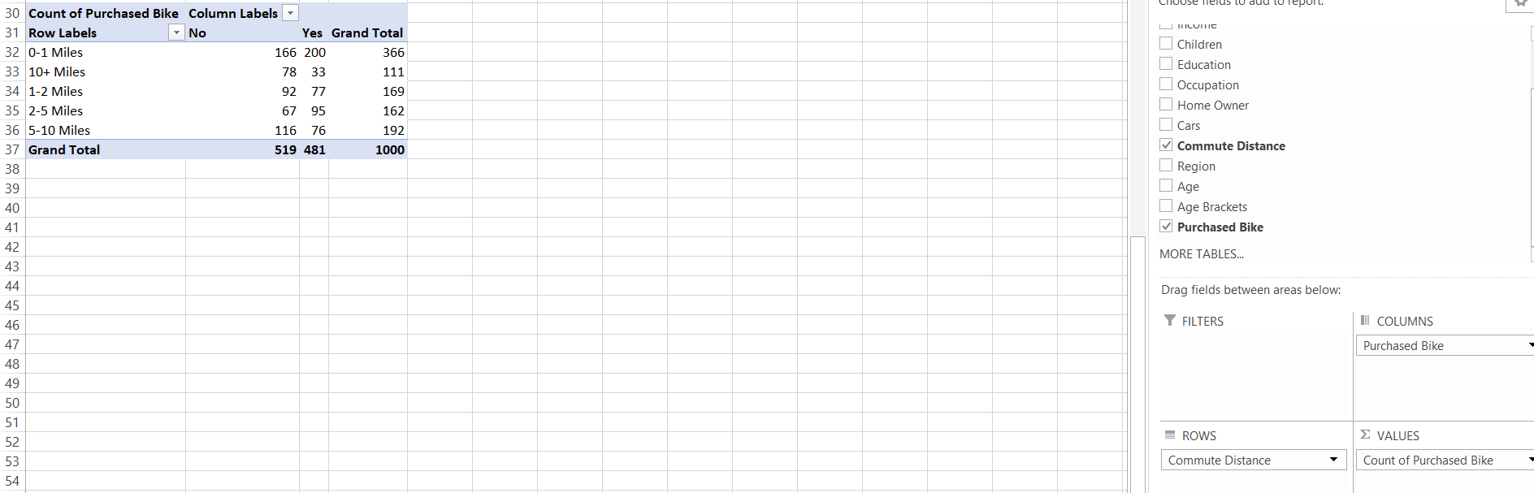

We can change that in the worksheet where we copy our data for the pivot table. After that refresh the pivot table

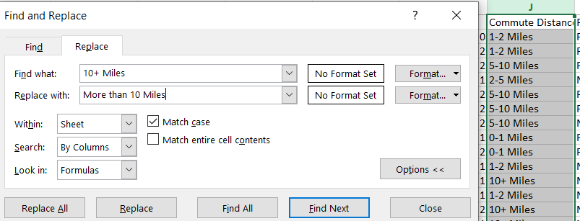 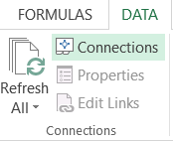

After you make a chart from the pivot table, you can copy the pivot table and modify it to create another chart

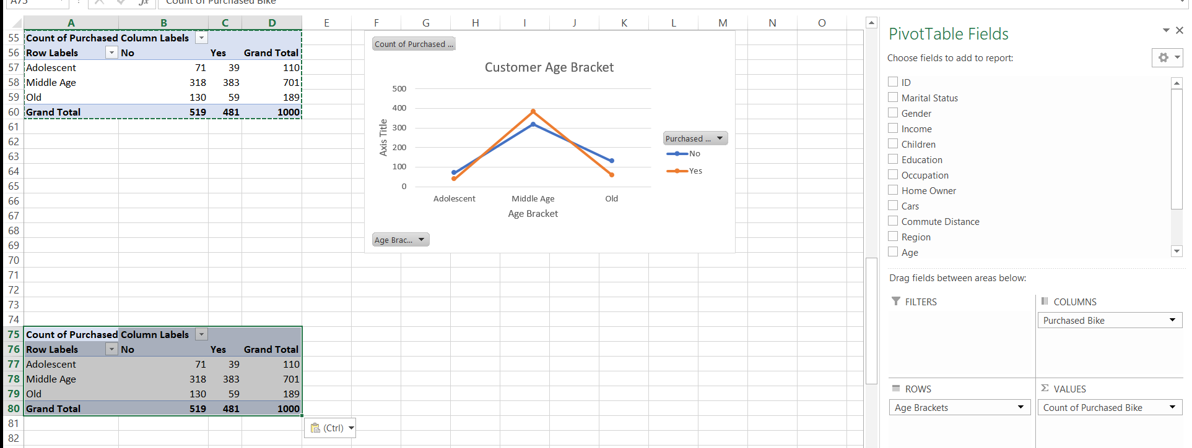

Creating Dashboard

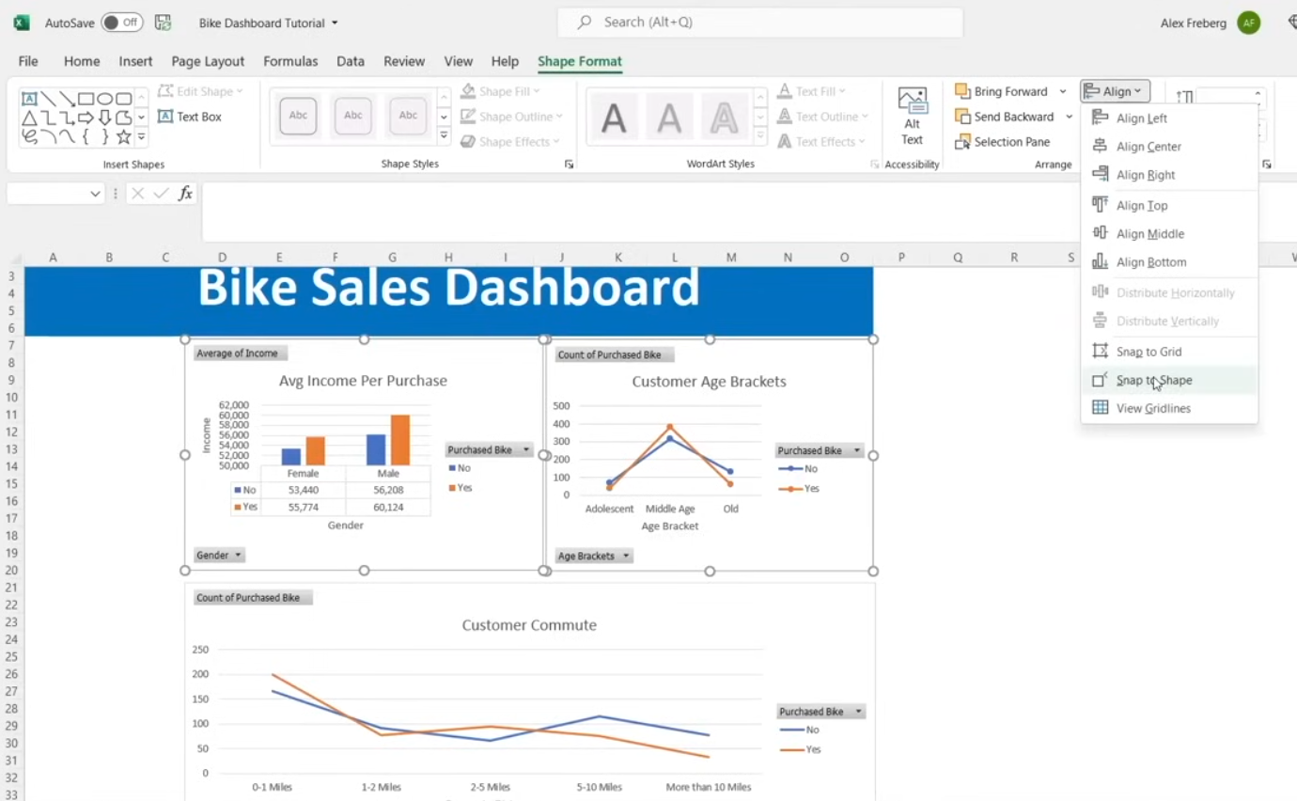

SLICER – is used to change the chart based on the filter data. slicer can only be made from one chart. If you try to select all chart, ‘Analyze’ section will not appear

Select Chart - > ANALYZE -> Insert Slicer

The slicer will be applied to ONLY one chart because that what you only selected

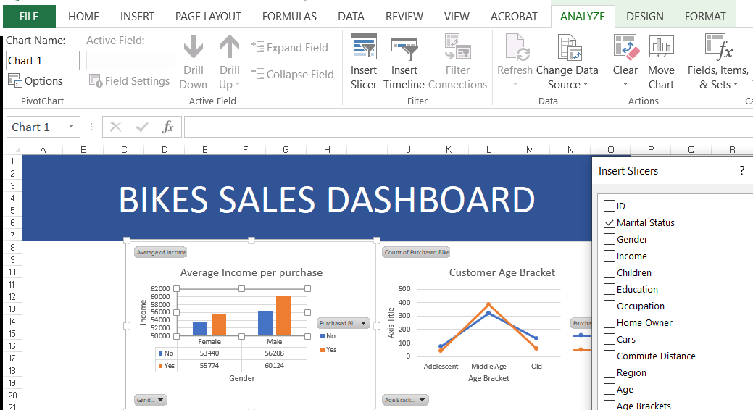

To be able to apply current slicer to all the chart CLICK/SELECT the slicer -> OPTIONS -> REPORT CONNECTIONs the check all the pivot table to include in the slicer, the chart is connected to the pivot table

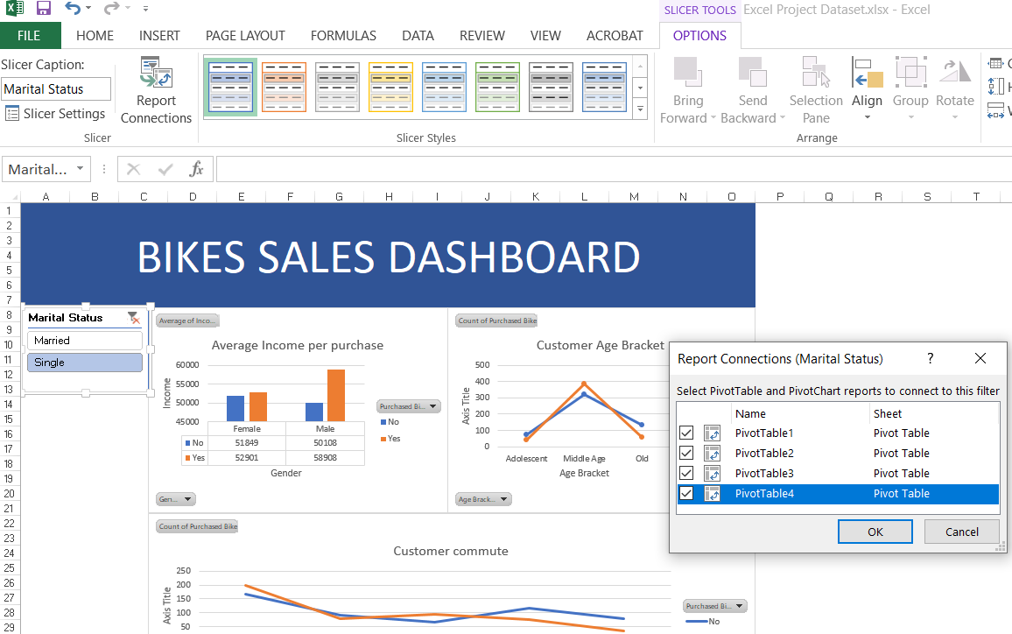

Add more slicer and use ‘Report connection” to add chart to the slicer.

